**CLOUD COMPUTING NOTES UNIT III**

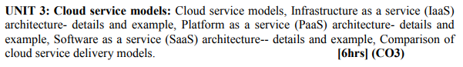

# 

# CLOUD SERVICE MODELS

## Introduction

Cloud computing is based on the Service model.

## Categories of service model

**The service models are categorized into three basic models:**

1) Software-as-a-Service (SaaS)

2) Platform-as-a-Service (PaaS)

3) Infrastructure-as-a-Service (IaaS)

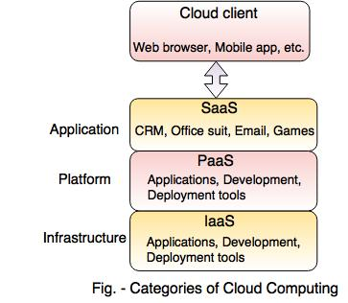

### 1) Software-as-a-Service (SaaS)

SaaS is known as **'On-Demand Software'.** It is a software distribution model. In this model, the applications are hosted by a cloud service provider and publicized to the customers over the internet. In SaaS, associated data and software are hosted centrally on the cloud server. Users can access SaaS by using a thin client through a web browser. CRM, Office Suite, Email, games, etc. are the software applications which are provided as a service through the Internet. The companies like Google, Microsoft provide their applications as a service to the end users.

### 

### 2) Platform-as-a-Service (PaaS)

PaaS is a programming platform for developers. This platform is generated for the programmers to create, test, run and manage the applications. A developer can easily write the application and deploy it directly into the PaaS layer. PaaS gives the runtime environment for application development and deployment tools. Google Apps Engine(GAE), Windows Azure, SalesForce.com are the examples of PaaS

### 3) Infrastructure-as-a-Service (IaaS)

IaaS is a way to deliver a cloud computing infrastructure like server, storage, network and operating system. The customers can access these resources over cloud computing platforms i.e Internet as an on-demand service. In IaaS, you buy complete resources rather than purchasing server, software, datacenter space or network equipment. IaaS was earlier called Hardware as a Service(HaaS). It is a Cloud computing platform based model. HaaS differs from IaaS in the way that users have the bare hardware on which they can deploy their own infrastructure using most appropriate software.

# Infrastructure as a Service (IaaS) in Cloud Computing

IaaS is the most basic layer of a cloud computing service model. The other two fundamental layers are [PaaS (platform-as-a-service)](https://www.mongodb.com/cloud-explained/paas-platform-as-a-service) and SaaS (software-as-a-service). The IaaS layer consists of the hardware required to host an application, i.e., network, compute, and storage resources. All the physical resources or hardware—like laptops, desktops, cables, switches, routers, data centers, and storage devices—are a part of infrastructure. In cloud computing, all the infrastructure is virtualized and provided to consumers as a service. This is called IaaS.

IaaS provides organizations with good control and management on their applications, without having to maintain the infrastructure, i.e., the physical resources.

IaaS gives more control and flexibility to cloud consumers, as they still manage the other two layers, whereas SaaS speeds up the time to bring an application to the market because it’s fully managed by the cloud provider.

If we were to keep the cloud computing service models on a stack, IaaS would be at the bottom, followed by the PaaS and then the SaaS layer on the top.

## **IaaS Architecture**

IaaS primarily consists of network, storage, servers, and the virtualization layers. We need a network to communicate between the virtualization, storage, and compute components, and to communicate to other service layers as well.

### **Network**

Network consists of resources like bridge, gateway, router, and switches that are virtualized before the cloud consumer can access them.

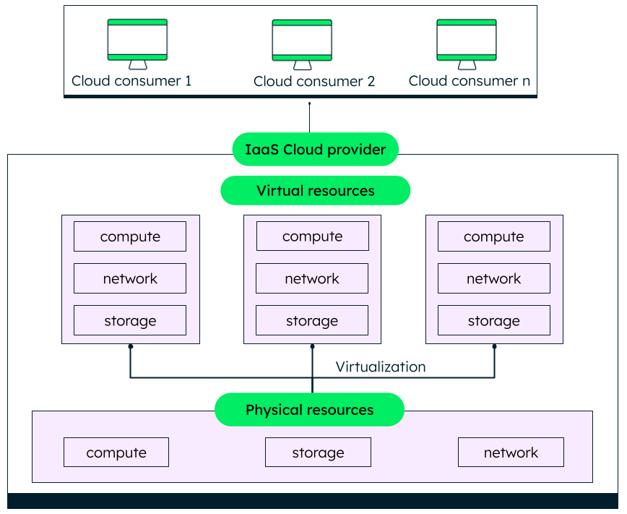

*Basic components of IaaS, namely, compute, network and storage*

### **Storage**

The most common type of cloud storage is object storage, which is inexpensive and can store any type of unstructured data including images, documents, blobs, and binary data.

Some object storage providers are Google cloud storage, Azure blob storage, and AWS S3.

Block storage splits data into blocks, allowing it to be spread across various platforms—for example, hard disks and SSD. File storage stores data in an organized, hierarchical structure. Examples are shared file systems and Network Attached Storage devices (NAS).

### **Compute :** Compute layer consists of:

* Central processing units (CPU) for processing web requests and running applications.
* Graphical processing units (GPU) that handle workloads like training algorithms and embedded systems.
* High performance units that perform advanced complex calculations for science and engineering workloads.

### **Virtualization**

All the physical resources are virtualized using a hypervisor before they can be accessed by the cloud consumer (subscriber). Consumers can access the infrastructure from anywhere using an internet connection, or a virtual private network (VPN) for additional security.

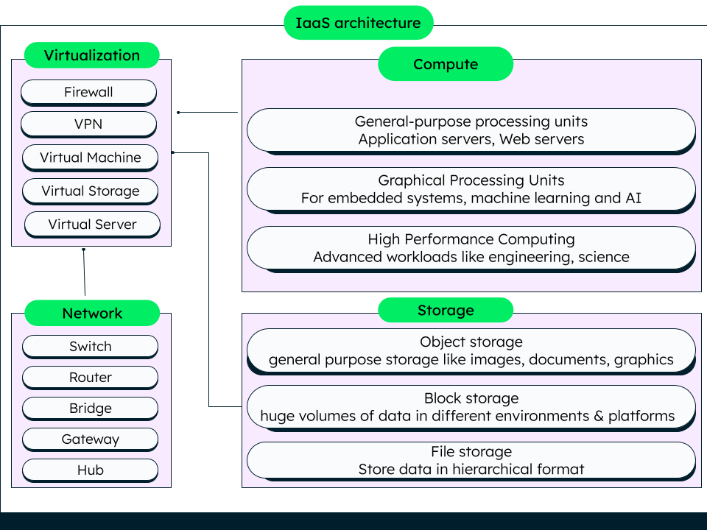

*Basic architecture of IaaS with the fundamental components, i.e. storage, compute, network, virtualization*

### **Additional offerings**

Depending on the organization’s business needs, cloud providers can also offer security, load balancing, monitoring, clustering, log access, backup and recovery, replication, and [serverless architecture offerings](https://www.mongodb.com/blog/post/serverless-architectures-the-evolution-of-cloud-computing). These can provide the organization with the necessary level of control and automation they want. The cloud provider has [virtual machines](https://www.mongodb.com/cloud-explained/virtual-machines) that the subscriber (organization) can use to install their choice of operating system, software, database, and other components.

In the above example of an IaaS architecture, the system admin manages the virtualized storage resources and the compute resources. VM automation helps in reducing the time taken for maintenance of the logical infrastructure (IaaS). Load balancing can be done for better performance and higher availability. Firewall provides the necessary security for clients to access the application.

## **How does IaaS work?**

In an IaaS environment, the cloud provider acts as a host to the resources needed by the cloud consumers (typically system admins). Cloud consumers can access the resources virtually with an internet connection to run their applications and workloads. IaaS provider performs the following:

* Maintains network resources, compute resources, storage resources, and data center infrastructure.
* Provides maintenance-free virtualized access to the hardware or infrastructure resources (mentioned above) on a pay-as-you-go basis.
* Creates a continuous virtual environment for cloud consumers.
* Provides easy access and control over individual IaaS components to the cloud consumers.

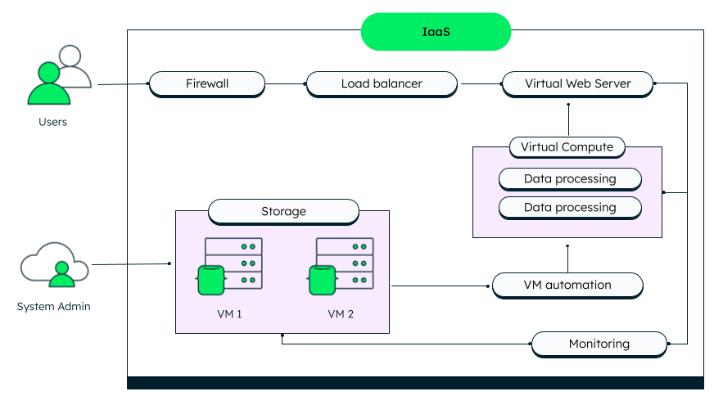

*Example IaaS architecture with basic components and additional offerings*

**Advantages of IaaS cloud computing layer**

There are the following advantages of IaaS computing layer -

**1. Shared infrastructure :** IaaS allows multiple users to share the same physical infrastructure.

**2. Web access to the resources :** Iaas allows IT users to access resources over the internet.

**3. Pay-as-per-use model :** IaaS providers provide services based on the pay-as-per-use basis. The users are required to pay for what they have used.

**4. Focus on the core business :** IaaS providers focus on the organization's core business rather than on IT infrastructure.

**5. On-demand scalability :** On-demand scalability is one of the biggest advantages of IaaS. Using IaaS, users do not worry about upgrading software and troubleshoot the issues related to hardware components.

## Disadvantages of IaaS cloud computing layer

**1. Security :** Security is one of the biggest issues in IaaS. Most of the IaaS providers are not able to provide 100% security.

**2. Maintenance & Upgrade:** Although IaaS service providers maintain the software, they do not upgrade the software for some organizations.

**3. Interoperability issues:** It is difficult to migrate VM from one IaaS provider to the other, so the customers might face problems related to vendor lock-in.

## **Some important point about IaaS cloud computing layer**

1. The IaaS cloud computing platform cannot replace the traditional hosting method, but it provides more than that, and each resource which is used is predictable as per the usage.
2. The IaaS cloud computing platform may not eliminate the need for an in-house IT department. It will be needed to monitor or control the IaaS setup. IT salary expenditure might not reduce significantly, but other IT expenses can be reduced.
3. Breakdowns at the IaaS cloud computing platform vendor's can bring your business to the halt stage. Assess the IaaS cloud computing platform vendor's stability and finances. Make sure that SLAs (i.e., Service Level Agreement) provide backups for data, hardware, network, and application failures. Image portability and third-party support is a plus point.
4. The IaaS cloud computing platform vendor can get access to your sensitive data. So, engage with credible companies or organizations. Study their security policies and precautions.

**Examples:** Top Iaas Providers who are providing IaaS cloud computing platform

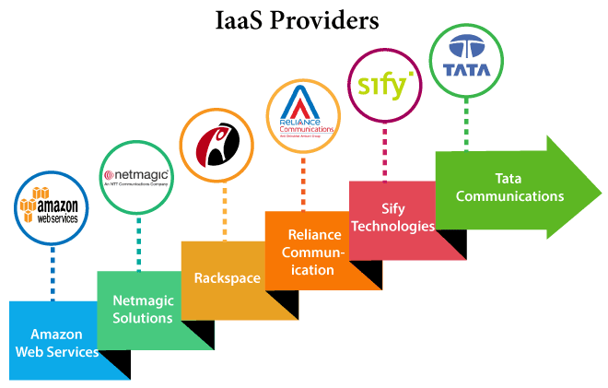

| **IaaS Vendor** | **Iaas Solution** | **Details** |
| --- | --- | --- |
| Amazon Web Services | Elastic, Elastic Compute Cloud (EC2) MapReduce, Route 53, Virtual Private Cloud, etc. | The cloud computing platform pioneer, Amazon offers auto scaling, cloud monitoring, and load balancing features as part of its portfolio. |
| Netmagic Solutions | Netmagic IaaS Cloud | Netmagic runs from data centers in Mumbai, Chennai, and Bangalore, and a virtual data center in the United States. Plans are underway to extend services to West Asia. |
| Rackspace | Cloud servers, cloud files, cloud sites, etc. | The cloud computing platform vendor focuses primarily on enterprise-level hosting services. |
| Reliance Communications | Reliance Internet Data Center | RIDC supports both traditional hosting and cloud services, with data centers in Mumbai, Bangalore, Hyderabad, and Chennai. The cloud services offered by RIDC include IaaS and SaaS. |
| Sify Technologies | Sify IaaS | Sify's cloud computing platform is powered by HP's converged infrastructure. The vendor offers all three types of cloud services: IaaS, PaaS, and SaaS. |
| Tata Communications | InstaCompute | InstaCompute is Tata Communications' IaaS offering. InstaCompute data centers are located in Hyderabad and Singapore, with operations in both countries. |

# 

# **Platform as a Service (PaaS)**

PaaS offers a complete environment for developers to run their applications. The environment includes hardware, routers, operating system, runtime environment, middleware, database, web server, and more. PaaS users, like developers, can deploy their applications on the PaaS provider’s infrastructure and platform.

PaaS provides the infrastructure and platform for developers to host their applications. Developers only need to worry about their application code. The providers host the required hardware and software so that the organization (developers) does not have to install anything on their machines. Examples of PaaS providers are SAP, Heroku, Microsoft Azure, VMWare, Google App Engine, and Swisscom. [Swisscom has built its New Application Cloud PaaS](https://www.mongodb.com/blog/post/leaf-in-the-wild-swisscom-builds-its-new-application-cloud-paas-for-microservices) for Microservices with MongoDB Enterprise Advanced. MongoDB is also the core content management component of [SAP’s PaaS offering](https://www.mongodb.com/press/mongodb-selected-core-content-management-component-saps-platform-service-paas-offering) and [VMWare’s PaaS](https://www.mongodb.com/blog/post/cloudfoundry-mongodb-and-nodejs).

### 

### **PaaS components**

PaaS components may include infrastructure (IaaS), middleware, OS, web server, runtime environment, database, and business intelligence tools.

#### **Middleware**

Middleware handles the common services and utilities like messaging, API management, data streaming, and authentication.

#### **Operating systems (OS)**

OS provides common services and manages software and hardware resources.

#### **Runtime environment**

#### Runtime environment provides common facilities on top of the operating system for applications built on a particular programming language to run smoothly.

#### **Database management**

#### Database management systems manage read and write operations between the database and the system requesting information.

#### **Infrastructure**

PaaS automatically includes the IaaS offerings of a cloud provider. This includes the compute, storage, and network requirements of an application.

### **PaaS Characteristics**

Here are some key characteristics of PaaS:

* Follows multitenancy in a public cloud environment, i.e., multiple customers can share the same compute resources at a given time.
* Provides tools and other software to build applications and a user interface for organizations to work with.
* [Automatic scaling](https://www.mongodb.com/post/14507562681/looking-to-scale-mongodb-on-the-cloud-try-a-paas), load balancing, failover handling.
* No installations—hardware or software.
* Integration with other cloud computing components like web services and databases.
* Provides build and deployment tools enabling shorter development cycles.

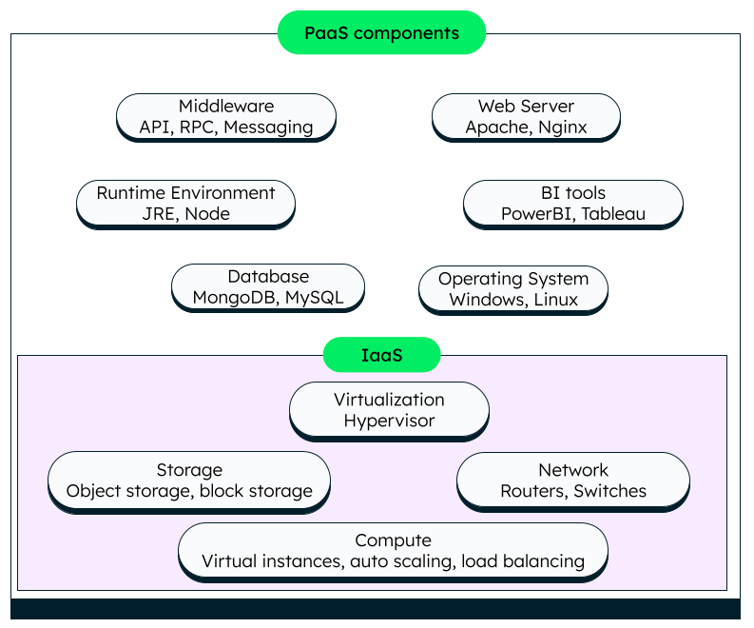

*The image represents the major components of PaaS*

## **How PaaS Works**

As we move up the cloud computing layers from IaaS to PaaS to SaaS, there is more abstraction and less complexity for the cloud service users. IaaS is the most complex, while SaaS provides the highest abstraction. PaaS offers a good balance of application control and abstraction for developers. Platform-as-a-service products are provided as web-based services via an interface.

Originally, PaaS was used for applications on the public cloud, but later expanded to private and hybrid types. We can see public PaaS as a layer between the SaaS and IaaS layers. Private PaaS can be deployed on the organization’s private cloud or on a public IaaS, if need be.

Cloud providers can deliver PaaS services through public, private, and hybrid cloud types.

## **Advantages of PaaS**

There are the following advantages of PaaS -

**1) Simplified Development**

PaaS allows developers to focus on development and innovation without worrying about infrastructure management.

**2) Lower risk**

No need for up-front investment in hardware and software. Developers only need a PC and an internet connection to start building applications.

**3) Prebuilt business functionality**

Some PaaS vendors also provide already defined business functionality so that users can avoid building everything from very scratch and hence can directly start the projects only.

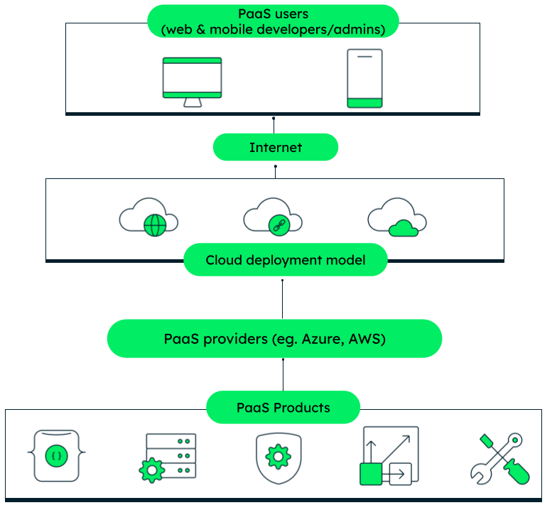

*How PaaS works*

**4) Instant community**

PaaS vendors frequently provide online communities where the developer can get the ideas to share experiences and seek advice from others.

**5) Scalability**

Applications deployed can scale from one to thousands of users without any changes to the applications.

## Disadvantages of PaaS cloud computing layer

**1) Vendor lock-in**

One has to write the applications according to the platform provided by the PaaS vendor, so the migration of an application to another PaaS vendor would be a problem.

**2) Data Privacy**

Corporate data, whether it can be critical or not, will be private, so if it is not located within the walls of the company, there can be a risk in terms of privacy of data.

**3) Integration with the rest of the systems applications**

It may happen that some applications are local, and some are in the cloud. So there will be chances of increased complexity when we want to use data which in the cloud with the local data.

## **Popular PaaS Providers**

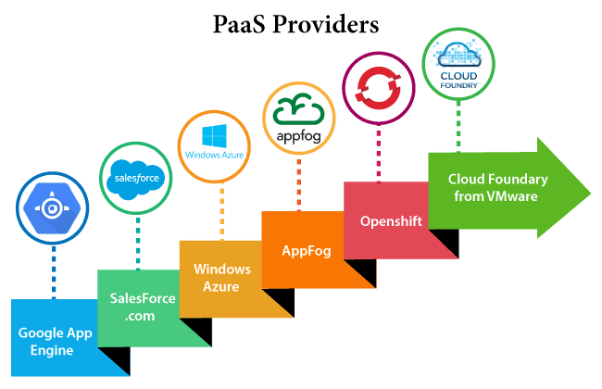

The below table shows some popular PaaS providers and services that are provided by them -

| **Providers** | **Services** |
| --- | --- |
| Google App Engine (GAE) | App Identity, URL Fetch, Cloud storage client library, Logservice |
| Salesforce.com | Faster implementation, Rapid scalability, CRM Services, Sales cloud, Mobile connectivity, Chatter. |
| Windows Azure | Compute, security, IoT, Data Storage. |
| AppFog | Justcloud.com, SkyDrive, GoogleDocs |
| Openshift | RedHat, Microsoft Azure. |
| Cloud Foundry from VMware | Data, Messaging, and other services. |

## 

## **What is SaaS?**

SaaS stands for Software-as-a-Service. It is a [cloud computing](https://www.mongodb.com/cloud-database/cloud-computing)-based service that is generally subscription-based. The idea behind SaaS is that as a client, you do not need to worry about the underlying hardware and infrastructure to run an application and can access it from anywhere, when required, as long as you have a stable internet connection.

## **How does Software-as-a-Service work?**

Software-as-a-Service (SaaS) is usually delivered via the cloud. A vendor will host their application on the cloud. They will take care of maintenance, updates, and infrastructure. The vendor may host the application on their own cloud service if applicable, or use a third-party cloud provider such as Azure, Amazon Web Services (AWS), or Google Cloud Platform (GCP).

The users of the software can then access the applications via the internet, often from a web browser, usually with a subscription to control access.

## **SaaS architecture**

SaaS applications often use a multitenant approach. This means that the software is hosted only once, but is available for each subscribed user or tenant.

The users won’t see that the application is actually one single instance of the server or cloud host, but it means only one single managed instance for the vendor.

The data is segregated between users which means privacy, with no data shared unless requested.

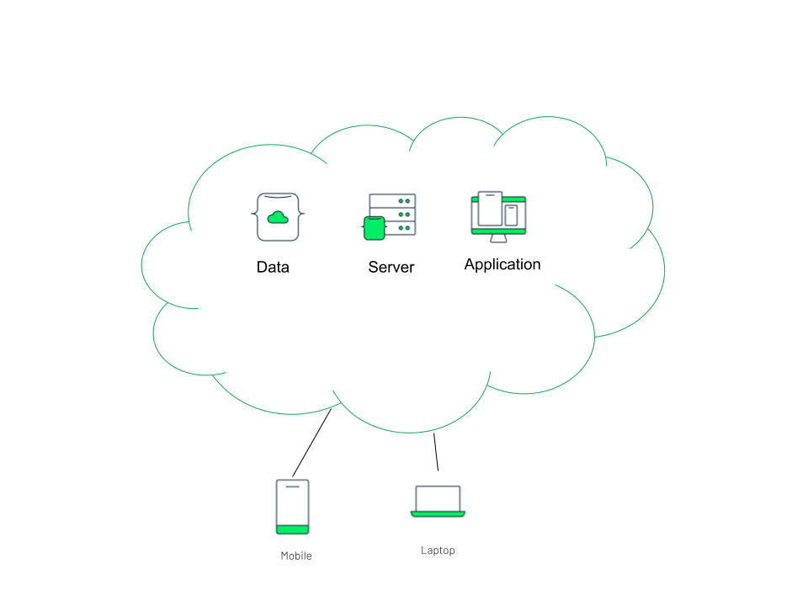

## **Software-as-a-Service characteristics**

Although not always sharing the same characteristics, the following list is applicable to most SaaS examples:

**Multitenant architecture**

* All applications and users have access to a single, common infrastructure that is centrally maintained.

**Improved access**

* Because SaaS applications are often cloud-hosted, the applications are available anywhere from a device connected to the internet.

**Customization**

* It is common for SaaS providers to add the ability to customize their products in a limited way to add logos or branding to the tenant of the application. This won’t affect the functionality but adds a look-and-feel that matches the client brand.
* Additionally, it is also possible to configure the application, to control what functionality is or isn’t available. Pricing might change depending on the functionality enabled on the tenant.

**Faster updates**

* A centrally managed application such as a SaaS program can more easily be updated due to only needing to make changes in one location. This leads to more frequent updates for maintenance and new features.

**Integration**

* Application Programming Interfaces (APIs) are often made available to allow for integration with client systems. SaaS applications cannot access clients’ internal systems and data, so APIs mean that integration can happen between the SaaS application and other pieces of software.

SaaS pricing is based on a monthly fee or annual fee subscription, so it allows organizations to access business functionality at a low cost, which is less than licensed applications.

Unlike traditional software, which is sold as a license with an up-front cost (and often an optional ongoing support fee), SaaS providers are generally pricing the applications using a subscription fee, most commonly a monthly or annually fee.

**2. One to Many**

SaaS services are offered as a one-to-many model meaning a single instance of the application is shared by multiple users.

**3. Less hardware required for SaaS**

The software is hosted remotely, so organizations do not need to invest in additional hardware.

**4. Low maintenance required for SaaS**

Software as a service removes the need for installation, set-up, and daily maintenance for the organizations. The initial set-up cost for SaaS is typically less than the enterprise software. SaaS vendors are pricing their applications based on some usage parameters, such as a number of users using the application. So SaaS does easy to monitor and automatic updates.

**5. No special software or hardware versions required**

All users will have the same version of the software and typically access it through the web browser. SaaS reduces IT support costs by outsourcing hardware and software maintenance and support to the IaaS provider.

**6. Multidevice support**

SaaS services can be accessed from any device such as desktops, laptops, tablets, phones, and thin clients.

**7. API Integration**

SaaS services easily integrate with other software or services through standard APIs.

**8. No client-side installation**

SaaS services are accessed directly from the service provider using the internet connection, so do not need to require any software installation.

## **Disadvantages of SaaS cloud computing layer**

**1) Security**

Actually, data is stored in the cloud, so security may be an issue for some users. However, cloud computing is not more secure than in-house deployment.

**2) Latency issue**

Since data and applications are stored in the cloud at a variable distance from the end-user, there is a possibility that there may be greater latency when interacting with the application compared to local deployment. Therefore, the SaaS model is not suitable for applications whose demand response time is in milliseconds.

**3) Total Dependency on Internet**

Without an internet connection, most SaaS applications are not usable.

**4) Switching between SaaS vendors is difficult**

Switching SaaS vendors involves the difficult and slow task of transferring the very large data files over the internet and then converting and importing them into another SaaS also.

The below table shows some popular SaaS providers and services that are provided by them -

| **Provider** | **Services** |
| --- | --- |
| Salseforce.com | On-demand CRM solutions |
| Microsoft Office 365 | Online office suite |
| Google Apps | Gmail, Google Calendar, Docs, and sites |
| NetSuite | ERP, accounting, order management, CRM, Professionals Services Automation (PSA), and e-commerce applications. |
| GoToMeeting | Online meeting and video-conferencing software |
| Constant Contact | E-mail marketing, online survey, and event marketing |
| Oracle CRM | CRM applications |
| Workday, Inc | Human capital management, payroll, and financial management. |

## **Popular SaaS Providers**

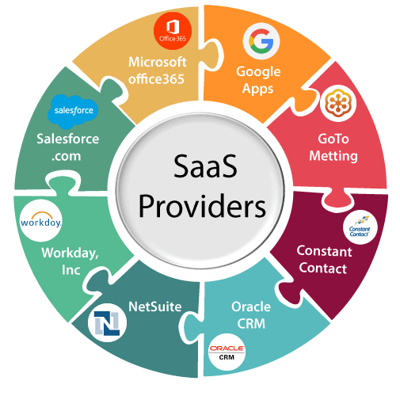

# **Difference between IAAS, PAAS and SAAS**

**1. IAAS:** Infrastructure As A Service (IAAS) is a means of delivering computing infrastructure as on-demand services. It is one of the three fundamental cloud service models. The user purchases servers, software data center space, or network equipment and rents those resources through a fully outsourced, on-demand service model. It allows dynamic scaling and the resources are distributed as a service. It generally includes multiple-users on a single piece of hardware.

It totally depends upon the customer to choose its resources wisely and as per need. Also, it provides billing management too.

**2. PAAS:** Platform As A Service (PAAS) is a cloud delivery model for applications composed of services managed by a third party. It provides elastic scaling of your application which allows developers to build applications and services over the internet and the deployment models include public, private and hybrid.

Basically, it is a service where a third-party provider provides both software and hardware tools to the cloud computing. The tools which are provided are used by developers. PAAS is also known as Application PAAS. It helps us to organize and maintain useful applications and services. It has a well-equipped management system and is less expensive compared to IAAS.

**3. SAAS:** Software As A Service (SAAS) allows users to run existing online applications and it is a model software that is deployed as a hosting service and is accessed over Output Rephrased/Re-written Text the internet or software delivery model during which software and its associated data are hosted centrally and accessed using their client, usually an online browser over the web. SAAS services are used for the development and deployment of modern applications.

It allows software and its functions to be accessed from anywhere with a good internet connection device and a browser. An application is hosted centrally and also provides access to multiple users across various locations via the internet.

**Difference between IAAS, PAAS and SAAS :**

| **Basis Of** | **IAAS** | **PAAS** | **SAAS** |
| --- | --- | --- | --- |
| **Stands for** | Infrastructure as a service. | Platform as a service. | Software as a service. |
| **Uses** | IAAS is used by network architects. | PAAS is used by developers. | SAAS is used by the end user. |
| **Access** | IAAS gives access to resources like virtual machines and virtual storage. | PAAS gives access to the run time environment to deployment and development tools for application. | SAAS gives access to the end user. |
| **Model** | It is a service model that provides virtualized computing resources over the internet. | It is a cloud computing model that delivers tools that are used for the development of applications. | It is a service model in cloud computing that hosts software to make it available to clients. |
| **Technical understanding.** | It requires technical knowledge. | Some knowledge is required for the basic setup. | There is no requirement about technicalities, the company handles everything. |
| **Popularity** | It is popular among developers and researchers. | It is popular among developers who focus on the development of apps and scripts. | It is popular among consumers and companies, such as file sharing, email, and networking. |
| **Percentage rise** | It has around a 12% increment. | It has around 32% increment. | It has about a 27 % rise in the cloud computing model. |
| **Usage** | Used by the skilled developer to develop unique applications. | Used by mid-level developers to build applications. | Used among the users of entertainment. |
| **Cloud services.** | Amazon Web Services, sun, vCloud Express. | Facebook, and Google search engine. | MS Office web, Facebook and Google Apps. |
| **Enterprise services.** | AWS virtual private cloud. | Microsoft Azure. | IBM cloud analysis. |
| **Outsourced cloud services.** | Salesforce | Force.com, Gigaspaces. | AWS, Terremark |
| **User Controls** | Operating System, Runtime, Middleware, and Application data | Data of the application | Nothing |
| **Others** | It is highly scalable and flexible. | It is highly scalable to suit the different businesses according to resources. | It is highly scalable to suit the small, mid and enterprise level business |

**Advantages of IaaS**

* The resources can be deployed by the provider to a customer’s environment at any given time.
* Its ability to offer the users to scale the business based on their requirements.
* The provider has various options when deploying resources including virtual machines, applications, storage, and networks.
* It has the potential to handle an immense number of users.
* It is easy to expand and saves a lot of money. Companies can afford the huge costs associated with the implementation of advanced technologies.
* Cloud provides the architecture.
* Enhanced scalability and quite flexible.
* Dynamic workloads are supported.

**Disadvantages of IaaS**

* Security issues are there.
* Service and Network delays are quite an issue in IaaS.

**Advantages of PaaS –**

* Programmers need not worry about what specific database or language the application has been programmed in.
* It offers developers the ability to build applications without the overhead of the underlying operating system or infrastructure.
* Provides the freedom to developers to focus on the application’s design while the platform takes care of the language and the database.
* It is flexible and portable.
* It is quite affordable.
* It manages application development phases in the cloud very efficiently.

**Disadvantages of PaaS**

* Data is not secure and is at big risk.
* As data is stored both in local storage and cloud, there are high chances of data mismatch while integrating the data.

**Advantages of SaaS**

* It is a cloud computing service category providing a wide range of hosted capabilities and services. These can be used to build and deploy web-based software applications.
* It provides a lower cost of ownership than on-premises software. The reason is it does not require the purchase or installation of hardware or licenses.
* It can be easily accessed through a browser along a thin client.
* No cost is required for initial setup.
* Low maintenance costs.
* Installation time is less, so time is managed properly.

**Disadvantages of SaaS**

* Low performance.
* It has limited customization options.
* It has security and data concerns.